Mrs. Stephanie & Mrs. Freedom’s Newsletter
January 26, 2024
What’s happening in our room?
My groups have been doing simple addition problems using manipulative and their fingers to count one
Mrs. Freedom’s group did a science experiment using Borax powder and heart shaped pipe cleaners.
What’s coming up?
2/1-2/2 Prek/K Online Registration
2/2 100th day of school
2/12 Cookie Dough Fundraiser

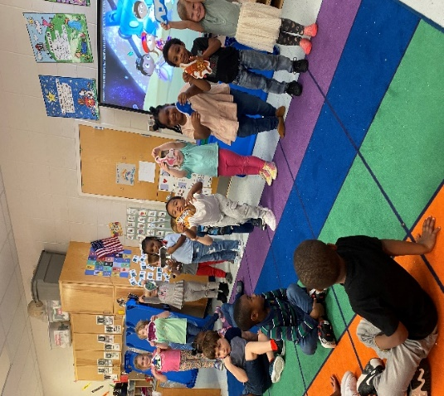
Need me?
sconnally@tcjackets.net , Seesaw or 229-225-3908

